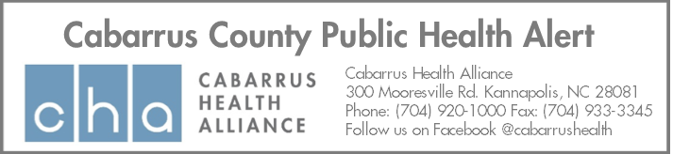
The pages that follow contain information critical to protecting the health of your patients and citizens of Cabarrus County.
November 17, 2020
Number of pages: 1
Subject: Education to providers for return to school – COVID-19
From: Cabarrus Health Alliance – School Health Department
The Cabarrus Health Alliance, Cabarrus County Schools, and Kannapolis City Schools are working diligently to implement strategies to mitigate the spread of COVID-19 in our schools. All North Carolina Public Schools are required to follow guidelines established in the Strong Schools NC Public Health Toolkit (https://files.nc.gov/covid/documents/guidance/Strong-Schools-NC-Public-Health-Toolkit.pdf). This includes specific information on excluding students from school who have fever, chills, shortness of breath/difficulty breathing, new cough, and/or new loss of taste or smell. Due to the increased rate of spread of COVID-19 between household contacts, all students and school staff who have symptomatic household members will not be allowed to enter a school building until specific return to school guidelines have been met.
Symptomatic students must meet one of the following requirements to be able to return to school:
- negative PCR COVID-19 test, no fever without the use of fever-reducing medicines and have felt well for 24 hours
- receive confirmation of an alternative diagnosis from a healthcare provider, no fever without the use of fever-reducing medicines and felt well for 24 hours
- at least 10 days have passed since the child developed symptoms, no fever without the use of fever-reducing medicines and felt well for 24 hours. Household contacts are required to quarantine for 14 days from the day of last contact or starting after the presumptive case’s isolation period if unable to completely isolate within the household.
(https://files.nc.gov/covid/PHT-ScreeningReferenceGuide_6.30.pdf )

If seen by a medical provider, students are required to provide documentation to the school of one of the above criteria being met. The health care provider is not required to provide specific details of the alternate diagnosis.

Please consider that public health departments are only made aware of COVID-19 cases that are verified through laboratory testing. Diagnoses that are based upon symptoms will not be reported and raise concerns with students who are attending school in-person and may have close contacts in the school setting.

We appreciate your partnership as we strive to protect the health of our community.

